Registering Via Club Registration Link

The steps below show how to create your PlayMetrics account through a registration URL provided by the Club.

- Click the registration URL link (or copy and paste it into your browser) and fill out the appropriate information. Enter the email address and password you would like to use for your account. Once you have done this, click the "Create Account" button to create your account.

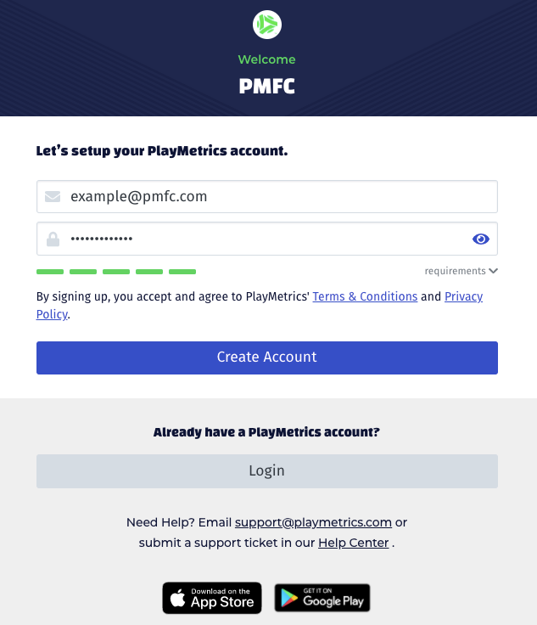

2. Our system will send a verification email for you to confirm your email address. Check the email inbox that you used to create your PlayMetrics account and verify your email address. After verifying your email address, you will be prompted to enter your contact information to complete your Parent or Guardian account.

3. Add your player information for each child you plan to register.

4. Based on the player information provided, you will be shown a list of programs available to each player.

For more information on how you register a player for a Club Program, please see the article "Registering a player for a program".

For more information on setting up your Player Contact account, please see the article "Setting Up Your Account: Parents & Players"
If you are still having trouble registering, please contact support@playmetrics.com and provide the following information:

- The name of your Club
- Your name
- Your player's name (if applicable)
- Email address you supplied to the Club
- The email App or Service you are using
- Description of your issue
- Phone number where we can reach you

